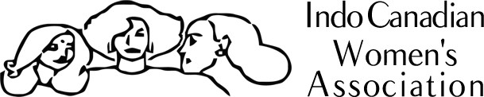

Annual Report, April 1, 2014-March 31, 2015

INDO CANADIAN WOMEN’S ASSOCIATION
Changing attitudes since 1984!
9342 34 AVENUE NW EDMONTON AB T6E5X8
PH: 780-490-0477. FAX: 780-490-0478
EMAIL:INFO@ICWAEDMONTON.ORG
WEBSITE: WWW.ICWAEDMONTON.ORG

Annual Report, April 1, 2014 - March 31, 2015

The Indo Canadian Women’s Association has been supporting new immigrants and women for the past thirty-one years. As an organization, the ICWA has unwaveringly ensured the integration and settlement of newcomers in Canada. Our approach to the prevention of violence against women focuses on raising the status of women through dialogue and community mobilization. Thus, an attitude shift in the treatment and portrayal of women is essential. We believe that small modifications in the attitudes about women can create an enormous impact in raising the status of women. This is why we are proud to say, “ICWA has been changing attitudes since 1984!”
Our vision is that all new Canadians will achieve a sense of fulfillment and integration into the Canadian culture and society. Everyone will have an equal opportunity to fully participate in Canadian society.
Our mission is to encourage and promote participation by new Canadians in social, economic, and political life in Canada. We are dedicated to promoting equality, opportunity, and protection of rights for everyone.

Celebrations and special events:

- Annual General Meeting

We began our year with our 30th Annual General Meeting (AGM). Held on the 31st of May, 2014, the ICWA held its 30th annual general meeting. Close to 35 members, supporters and special guests were in attendance. Avau Fast was a warm and welcoming host, followed by board president Miriam Thomas. Mita Das then introduced guest speaker Sohail Quadri, MLA. He congratulated the association on the milestone we have reached and our excellent reputation in both the East Asian community and the community at large. He said that his colleagues in the Alberta Legislature are well aware of the valuable contribution we are making, and that, "We would be lost as a province without your work". At the conclusion of his address he presented a plaque to the organization from the provincial government.

- International Day of Peace

On September 21st, the ICWA team was proud to attend and exhibit their work at the International Day of Peace celebrations held at City Hall. The day was filled with powerful speakers, invigorating diverse music and assorted dance to support the message of peace both locally and abroad. The ICWA team was honored to be a part of such a uniting event.

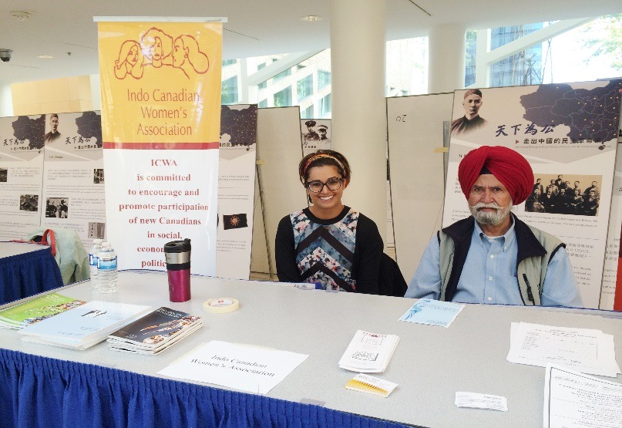

- International Day of the Girl Child

On October 17th, the ICWA held an intercultural function to honour the International Day of the Girl Child. About 35 guests were present in an evening of inspirational discussions and light refreshments. Attendees watched a movie and were asked to think critically about its content. Upon the end of the movie, the patrons expressed their feelings towards the film. The evening ended on a high note and everybody left inspired.

- Multicultural Festivities

On December 13, 2014, the ICWA held their annual Multicultural celebration. This year, we decided to highlight festivals that are observed year-round all over the world. We took into account popular celebrations from every creed. The guests were encouraged to participate in the program and representatives of every faith educated the congregation on various cultural traditions. The event ended with a delightful potluck lunch. It was a truly heart-warming, harmonious celebration!

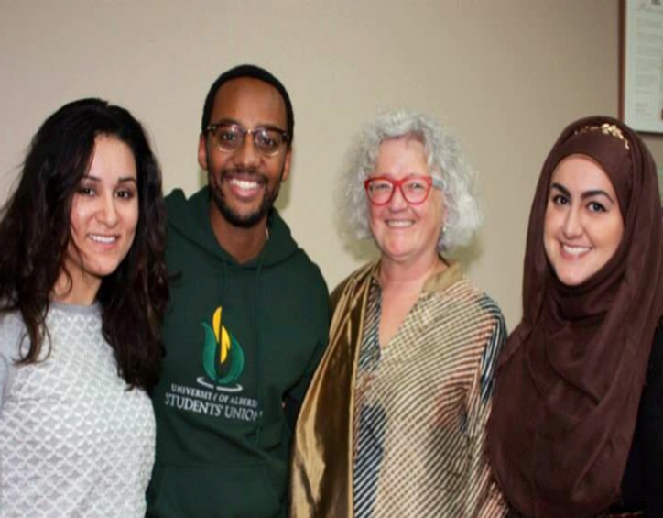

- International Women’s Day

International Women's Day has been observed since in the early 1900's. Annually, events are held worldwide to motivate women to make change as well as to celebrate their achievements. On March 28th, 2015, the Indo Canadian Women’s Association held their 31st annual International Women’s Day celebration. Our guest speaker for the evening was the CEO of the YWCA, Jacqueline Foord. She gave an empowering speech on the inclusion of women in leadership roles. As an advocate for the equality of women’s rights, she gave a touching presentation that moved the entire crowd. She touched very briefly on Canada’s history of discrimination based on gender and race. Jacqueline went on to discuss the types or barriers that immigrant women in Canada face and how these barriers hinder the progression of equality.
She provided words of advice to remove the stigmas that are placed on immigrant women, such as mental health. She concluded with encouraging notions that left everyone inspired. The audience then enjoyed our multicultural buffet dinner as well as some traditional Indian performances.

“Young immigrant women get the full force of gender discrimination plus they face a number of extra challenges because of the complexity of their lives. They struggle with identity, racism, language, culture, education, employment, mental health issues, violence, family responsibilities and intergenerational conflict. And remember those are over and above the everyday gender discrimination that they are subjected to. Each one of these issues is enormous in and of itself.” – Jacqueline Foord, CEO of the YWCA

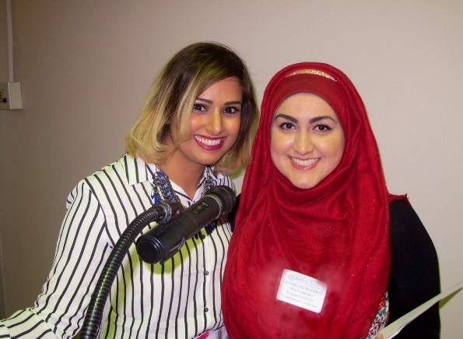

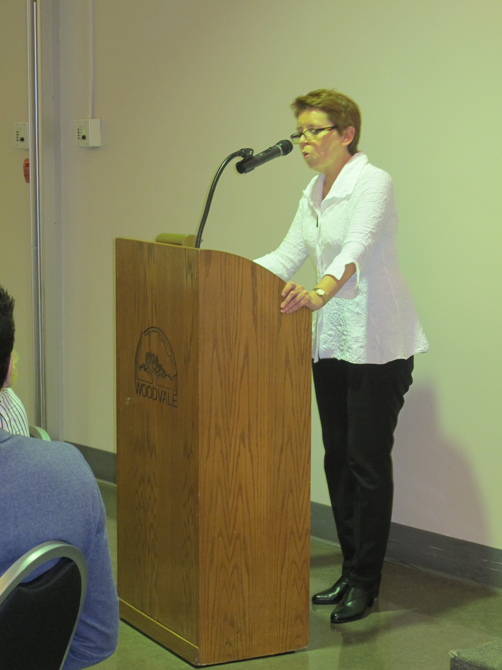

- Lunch with the Status of Women Canada

On April 9th, 2015, Meena Ballantyne (Head of Agency, Status of Women Canada), along with Deborah Welch (Director, Program Policy, Planning and Evaluation, Women's Program, SWC ), and Jody Brennan (Regional Director, Western Region Office, Women's Program, SWC) paid a visit to the Indo Canadian Women’s Association, along with two other representatives. Rajvir Gill, the Project Coordinator of Working Together, presented to the project that she had been working on for the past two years. The discussion was an informal meeting to discuss ICWA's work and emerging issues in the sector. The discussion also included an overview of the Working Together project. We spoke of the feedback obtained from community members and service providers on the issue of honour based violence and what barriers each face when working or dealing with the topic. While many gains were made with our training this past September for service providers and education to young girls, we have identified the need for a coordinated network and dialogue in Edmonton not only on honour based violence but on family violence in general. The Status of Women Canada representatives were very pleased to hear about the development of programs of the ICWA in regards to honor-based violence.

Trainings, conferences and presentations

- Training – awareness of forced marriage and “honor” related violence

On September 29 and 30th, the ICWA hosted a two day training to front line social service workers. The joint effort was provided by the Outburst team from Toronto -a partnership between the Barbra Schlifer Clinic and the South Asian Legal Clinic of Ontario. The first day focused on creating awareness on forced marriage and, “honor” related violence. The second day was a working day - looking at the best practices to develop a service delivery model for young women experiencing forced marriage. The hands-on skill building workshop series for front-line workers aimed at increasing the access to services for survivors by providing participants with:
* Increased knowledge of impact of "honor" related violence/forced marriage
* Promising practice tools and resources on prevention
* Information on family and immigration law
* Needs-assessment, safety planning and creative intervention strategies for addressing "honor" related violence/forced marriage

- Conference - Diverse Voices

On November 21st the Indo Canadian Women’s Association alongside the University of Calgary’s Faculty of Social Work presented our work on honor based violence (HBV) at the Diverse Voices conference. The Diverse Voices conference focuses on the complex issues around family violence and provides crucial education to service providers to be used when addressing family violence in their work. The presentation focused on promoting an understanding of the phenomenon of honor based violence and contextualize it within the broader framework of violence against women. The second aim of the workshop was to present the findings of the needs assessment and the multi-agency strategy that was developed with a focus component on training for service providers on the issue of HBV. The presentation was well received and connections to other service providers working on the issue were made. We would like to thank the Diverse Voices conference committee for their hard work and for including us in yet another successful event!

- Conference - “Tackling Early and Forced Marriage and Honor Based Violence in Canada”

On February 26th, the Indo Canadian Women’s Association attended the “Tackling Early and Forced Marriage and Honour Based Violence in Canada” conference in Ottawa, Ontario. The conference showcased over 20 experts on the issue of forced marriage and honour based violence. The discussions centered on the legal framework in Canada, what we know about honour based violence and forced marriage, how to respond to the issue with enforcement and prosecution, protecting children: extraterritorial issues and domestic legal challenges, and finally how to respond to victims. The keynote address was given by Jasvinder Sanghera , the Executive Director of Karma Nirvana, where she spoke about her experience as a forced marriage survivor and the process of criminalization of forced marriage in the United Kingdom. Jasvinder also shared the success of Karma Nirvana’s awareness campaigns, training, events, and the national Honour Network Helpline. Another point of discussion at the conference was the recent Zero Tolerance for Cultural Barbaric Practices Act. Two viewpoints were debated around the bill; one for the bill as a preventative measure and others seeing the bill as a way to marginalize racialized communities. Overall, the ICWA was privileged and thankful to gain more knowledge in the area of honour based violence and forced marriage, as well as network with other agencies across the country working on these issues.

- Conference – Exploring Family Violence with a Cultural Lens

On April 20th during National Victims of Crime Week, the Indo Canadian Women’s Association was proud to present along-side the Today Family Violence Help Centre and Catholic Social Services on the topic of “Exploring Family Violence with a Cultural Lens”. Organized by the Caring Community Collaboration, which formed in response to the need for improved access to community services and supports for immigrant and refugee families living in West Edmonton, there were over 30 service providers and community members in attendance. The workshop took a look at the definitions, local statistics and types of family violence, and explored barriers to helping and the realities of these barriers through a cultural lens. During the discussions we strategized as a group on some ways we can help and facilitated conversations with one another to explore our biases, perspectives and experiences around Family Violence.

- Presentation – Shield of Athena’s Honour Based Violence

The Indo Canadian Women’s Association is proud to be invited to speak at the Shield of Athena’s Honour Based Violence conference taking place in Montreal on May 19th and 20th. This conference specifically examines honour based violence and the nation wide initiatives done in the fields of intervention and in ethno cultural communities. The conference aims to raise awareness, create links between professionals from various sectors and encourage new collaborations to end honor based violence. We are proud to be sharing the results of our Status of Women funded project “Working Together- Engaging Communities to End Violence Against Women and Girls in the Name of Honour”.

Projects:

After two years of hard work, the “Working Together” project is coming to a close. This project was intended to raise awareness, educate youth and create a community initiative to better protect survivors and women and girls at risk of experiencing honour based violence. In this time the ICWA has changed their attitudes towards this type of violence and now position honour based violence within the realm of family violence and adopt a non-racist, non-cultural, feminist approach. Following this, we now assert that honour based violence can happen in any community and that it is not a direct proponent of culture. Additionally, the ICWA has been successful in working with their partners, YWCA Edmonton, Today Family Violence Help Centre and the John Humphrey Centre for Peace and Human Rights to educate youth, facilitate meeting between police, shelters and other organizations working on this issue and train Edmonton service providers to better understand the topic. We hope that the conversation of honour based violence will continue after the project ends and that Edmonton will be on their way to initiating better services and services models for those experiencing honour based violence.

Programs:

- Senior’s Group

Weekly, the ICWA senior's group holds sessions of 20-30 people who are typically over the age of 55. The majority of the attendees are of South Asian descent. This year, 600 seniors benefited from this group. These seniors were provided with light refreshments as they engaged in dialogue and activities with one-another. They learned to be mobile throughout the city using the public transportation. Guest speakers and instructors came to educate and engage them in interactive programs such as Yoga. They received professional assistance when it came to their taxes as well as their benefits. Three times during the year they were taken on field trips around the city such as: City Hall, Alberta Legislature Building and the Royal Alberta Museum. On November 25th, we celebrated another great year with our seniors.

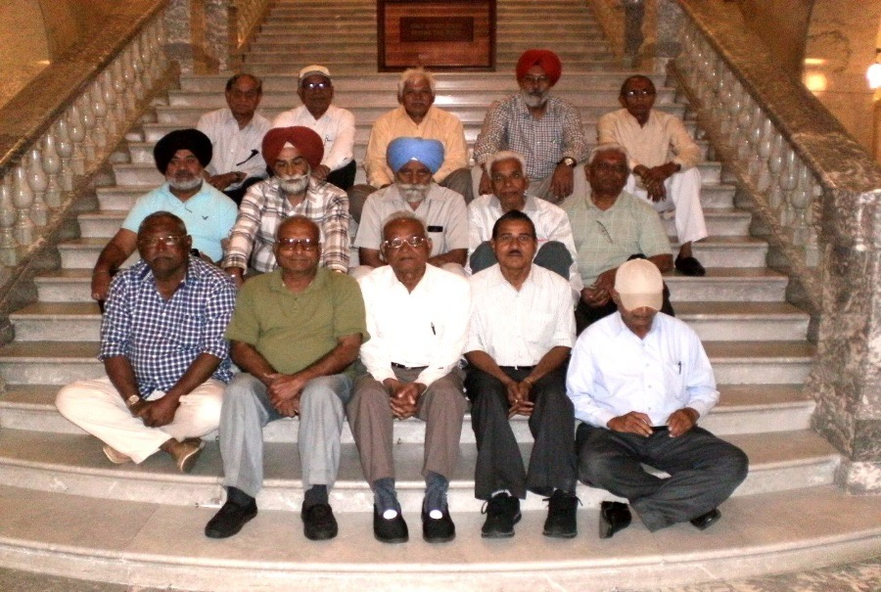

- Breast Health Awareness

The ICWA’s Breast Cancer Awareness project began in 2009 with the help of a grant from the Canadian Breast Cancer Foundation Prairies/Northwest Territories (NWT) Region. Since then, the ICWA has been proactively educating South Asian women about breast health. The goal of this initiative has been the detection of methods as well as the promotion of breast health education. The target population for this project are women who face barriers when accessing health care services. The journey from the diagnosis of breast cancer to its treatment seems to be longer and more difficult process for South Asian women when compared to non-South Asian women due to cultural barriers. This results in these women experiencing a whirlpool of emotions such as fear, loss, isolation, embarrassment, and feelings of low self-confidence. Hence, many women sidestep evidence-based treatments in hospitals. The women who attend our Breast Health program need a supportive network which fosters caring personnel who sincerely improve the lives of the clientele. We served 3292 clients this year. These clients were mostly of South Asian and Middle Eastern descent.

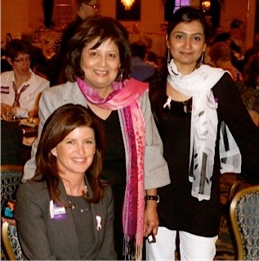

- English as a Second Language (ESL)

Our English as a Second Language (ESL) Adult Literacy Class coordinated by Chouaib El Bouhali empowers individuals with the language tools to successfully integrate and settle in Edmonton. In order to provide services to a maximum number of students, students are continually accepted into the program. We aim to have our students obtain basic skills in the English language such as speaking, reading, listening, grammar and writing. Our class is in high demand due to our practical teaching methods as well as our accessible location. This year, 36 students attended the (ESL) classes, 20 of which were women. The diverse backgrounds of the students involves a range of ethnicities such as Afghani, Pakistani, Moroccan, Tunisian, Somalian, Korean and El-Salvadorian.

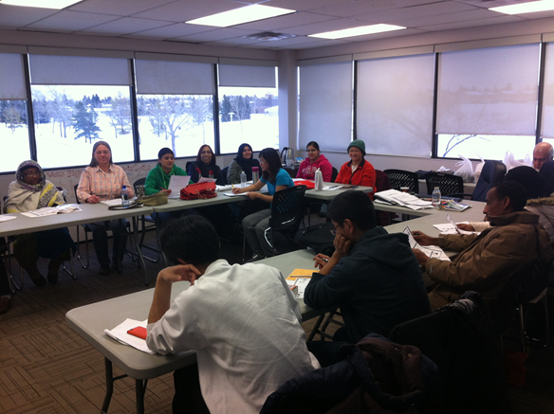

- Adult Literacy Class

Our Adult Literacy class language Learners are funded by ECALA. Taught by Farah Fatima, conversational skills are enhanced in these courses with an emphasis on speaking, grammar and comprehension. The friendly atmosphere of these courses allows for students to read and write comfortably without the fear of judgements. 72 students were served in these classes, 28 of which were men and 44 of which were women. Mostly, the students were of Indian background and there were some from the Middle East.
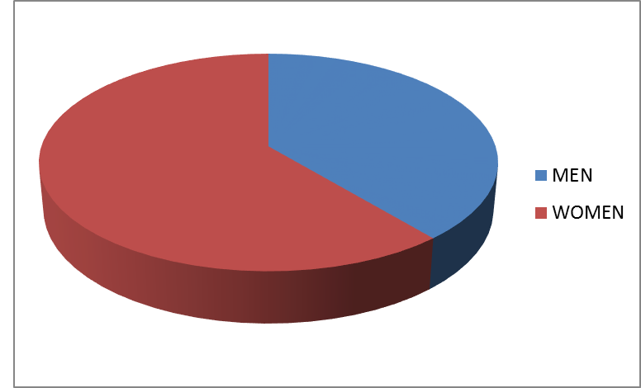
- Citizenship Preparation Class

Our Citizenship preparation instructed by Paul Kalsi provides students with essential information to fully understand their rights, responsibilities and values as Canadian citizens. This diverse class caters to people from multiple walks of life. The instructor spends considerable amounts of time ensuring that his students get the best possible experience with unique study material and efficient instruction. In total, this class served 206 students, half of which were women. This class had a 98% success rate. The students were of diverse backgrounds such as Argentinian, Portuguese, Indonesian, Cuban, Fijian, Moroccan, Sudanese, Egyptian, Finnish, Tanzanian, Chinese, Russian, Australian, Bolivian, Pakistani and Indian.

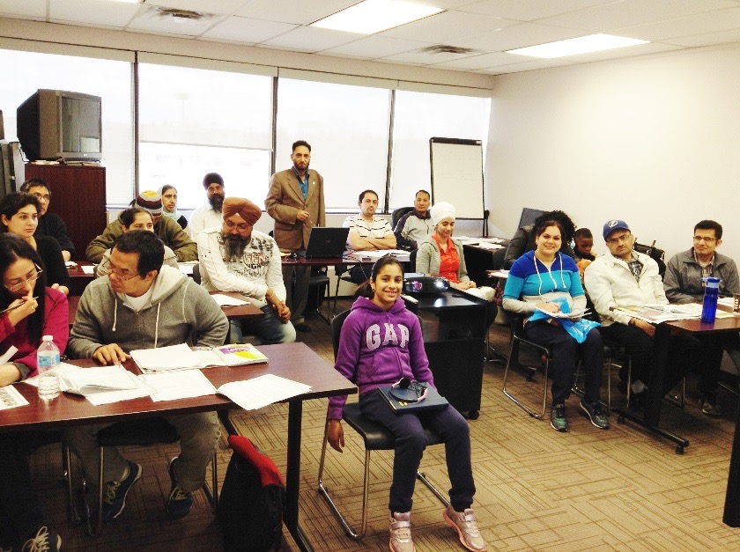

- Computer Class

Our Computer Literacy classes managed by Jaya Saxena, are offered at two levels: basic and intermediate. These classes are attractive to the adult population because they enhance employability. The classes equip our students with the confidence to apply to higher positions and advance in their careers. With the skills acquired from our classes, students are better able to integrate into the Canadian work environment. A greater socio-economic status gives our students independence. The ICWA gratefully acknowledges the funding of the ‘Edmonton Community Adult Learning Association’, for successfully running these classes. 95% of the students who attend these classes are Indian but other nationalities involve Pilipino and Egyptian. These classes are composed of 80% women and 20% men. This year, the Intermediate class served 15 students and the Basic class, 32.
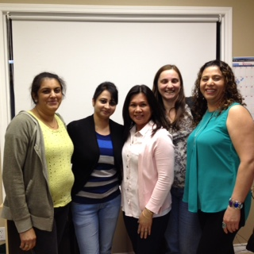

- Youth Development Program

Our Youth Development program, directed by Sogand Zakerhaghighi has shown an impressive increase in loyal attendees over the past year. Monthly, young adults from 15-25 years old, meet to discuss controversial topics such as sexism, racism, self-harm, abuse, and other taboo subjects. 70 participants attended these sessions in the past year. The participants were from a variety of ethnic backgrounds such as Ethiopian, Nigerian, Kenyan, Iranian, Afghan, Lebanese, Pakistani, Indian, Chinese, and Yemeni.

- Women’s Resiliency Group

The Women’s Resiliency Program is a means of support to newcomers. In these two hour bi-weekly sessions, we have had a steady attendance of ten to fifteen women per session. A variety of activities and workshops were designed to facilitate the processes of integration into Canadian society.

BI-WEEKLY SESSION ACTIVITY SCHEDULE
SESSION | DATE | ACTIVITY SCHEDULE
1 | APR 07, 2015 | INFORMATION SESSION: INTRODUCTION
2 | APR 13, 2015 | HEALTH SESSION: WOMEN’S HEALTH ISSUES
3 | APR 27, 2015 | SEWING CLASS 1: CUTTING
4 | MAY 11, 2015 | SEWING CLASS 2
5 | MAY 25, 2015 | SEWING CLASS 3
6 | JUN 08, 2015 | OUTDOOR ACTIVITY: PICNIC
7 | JUN 15, 2015 | SEWING CLASS 4
8 | JUN 22, 2015 | SEWING CLASS 5
9 | JUL 06, 2015 | HEALTH SESSION: EXERCISE ROUTINE
10 | JUL 20, 2015 | INFORMATION SESSION: SENIORS BENEFITS IN CANADA
11 | AUG 03, 2015 | OUTDOOR ACTIVITY
12 | AUG 17, 2015 | ART & CRAFT SESSION 1
13 | SEP 07, 2015 | ART & CRAFT SESSION 2
14 | SEP 21, 2015 | OUTDOOR ACTIVITY: LIBRARY TOUR
15 | OCT 05, 2015 | INFORMATION SESSION: CANADA FOOD GUIDE
16 | OCT 19, 2015 | INFORMATION SESSION: FAMILY SPONSORSHIP
17 | NOV 02, 2015 | INFORMATION SESSION: COPING WITH DEPRESSION
18 | NOV 16, 2015 | HEALTH SESSION: BREAST CANCER AWARENESS
19 | NOV 30, 2015 | INFORMATION SESSION: PROMOTING LEADERSHIP AMONG GIRLS
20 | DEC 14, 2015 | CHRISTMAS & NEW YEAR PARTY

PROPOSED ACTIVITIES FOR EXTENDED SESSIONS

It is recommended that these sessions be increased in frequency from the current 2, to 4 sessions in a month. This recommendation is based on client requests as well as the coordinator`s assessment for the need to impart more essential information to participants. Some essential topics that need to be covered are given below for consideration:
- Family Violence
- Spousal rights & support
- Housing in Canada
- Cross cultural parenting
- Financial Literacy
- Running a small business
- Canadian Charter of Rights & Responsibilities, Rights of PR & Citizens
- Volunteering in the Community
- Networking for Newcomers
- Life skills for survival in Canada
- Canadian Work-place Culture
- Time Management & Organizational Skills
These ideas will be developed further if required
Services:

- Settlement Counselling

The settlement and Adaptation Program and services of Newcomers to Canada are provided by Indo-Canadian Women’s Association Settlement counsellors. This program is funded by Citizenship and Immigration Canada. ICWA provides the Settlement Programs and Services from the Welcome Centre for Immigrants located in the Millbourne Mall of Millwood neighbourhood. There are two Full Time Settlement Counsellors hired by ICWA to provide settlement and integration services to new immigrants. The settlement councillor’s provide Settlement Orientation Sessions and one to one counselling to Newcomers to Canada.

CLEITNELE BY ORIGIN
Afganistan | 13 | 2%
Bangladesh | 19 | 2%
African Countries | 91 | 11%
Carribbean Islands | 11 | 1%
India | 388 | 49%
Korea | 11 | 1%
Pakistan | 118 | 15%
Philippines | 41 | 5%
South America | 9 | 1%
Sri Lanka | 19 | 2%
Central America | 4 | 1%
China | 4 | 1%
Europe | 28 | 4%
others | 42 | 5%
TOTAL | 798 | 100%

- Outreach:

There are two Outreach staff working for ICWA under the Immigration and Settlement Program to support newcomers living in hard to reach communities and have multiple barriers such as Language, Socio-economic, and mobility. The ICWA Outreach team regularly visits designated areas for Outreach presentations and meetings and also coordinates events to spread awareness among newcomers, as well as for the publicity of ICWA Settlement Services.

Awards:

- Daughter of the Year

On a sunny Saturday afternoon in early September 2014 the third Daughters Day celebration took place at Edmonton's City Hall. Since the event began in 2012, ICWA has been a key partner making this project possible through its support of Citizens for a Civil Society. The day included honouring 12 women as Daughters of the Year, including ICWA's own Rajvir Gill. The keynote address was by NorQuest president Jodi Abbott and there was entertainment, an information fair, and an educational walk.
In 2015 Daughters Day will be held on August 29 at City Hall. Nominations are now invited for Daughters of the Year. The form is available from the ICWA office or www.daughters-day.com. Daughters Day also published the book “Together- creating a better world” in 2014 that gathers ideas from 15 consultations with women, including one group that met at ICWA. A workshop to train women in community work using the book is now in development. And early in 2015 Daughters Day began to grow beyond Edmonton as the first celebration was held in Calgary.

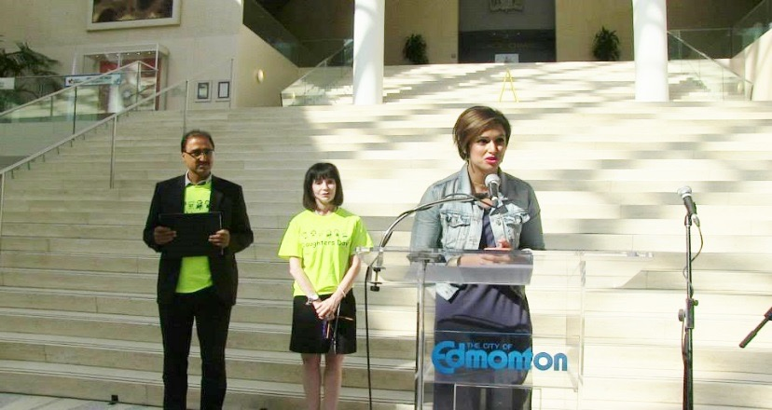

Publicity, Promotion, and Networking

Our quarterly newsletter has been a successful means to reach our community. We have used it to announce our programs, services and events. We send the newsletters out to our members, the women’s groups, and other ethnic, mainstream, government and non-government organizations to promote awareness of our initiatives and activities. The newsletter also is out potential tool to discuss issues related to women and immigrants, integration and multiculturalism.

Administration and Governance

- The Board of Directors

The Indo-Canadian Women’s Association is managed by a volunteer board that looks after its finance, governance, policy-making, project-supervision and day-to-day administration. All the members of the Board and the invited members-at-large are dedicated women with expertise and distinction in various walks of life. They dedicate their valuable time and services in many different ways. They help with writing funding proposals

Miriam Thomas—President
Nisha Bhatia – Vice President
Jagjeet Bhardwaj—Treasurer
Netta Phillet—Secretary
Gita Das—Director
Dr. Zohra Husani—Director
Ratna Basappa—Director
Navneet Kiran—Director
Avau Fast—Director
Judy Axelson—Director
Mita Das—Director
Saadat Chaudhary—Member-at-large

- Board Meetings: 500 hours
- Executive committee: 500 hours
- Standing committee work: 800 hours
- Program & project work: 1500 hours
- Total hours volunteered by board: 3000 hours
- 10 Board meetings
- 10-12 members in attendance
- 2-3 hours long/meeting

- The Staff

Rajvir Gill—Project Director
Sarah Russell—Project & Program Coordinator
Sogand Zakerhaghighi— Office Coordinator
Program Developer, Youth Program Director
Farah Fatima—Settlement Counsellor
Adult English class Instructor
Saima Tanwir—Settlement Counselor
Shazia Ambreen—Outreach Worker
Rajbir Kharod—Outreach Worker
Paul Kalsi—Outreach Worker (family and domestic violence)
Citizenship Instructor
Kishwar Ghani—Breast Health Educator
Jaya Saxsena—Computer Instructor
Chouaib El Bouhali—English as a Second Language
(ESL) Instructor

Acknowledgements:

- Sponsors

The Indo Canadian Women’s Association would like to express its gratitude to the following sponsors for their generous donations:

- Servus Credit Union
- James Brown & Associates
- Avau and Malcolm Fast
- The Singhmar Family
- Shorie Bhatia LLP
- Bhatia Khurana LLP
- Rohit Group of Companies

- Agency & Organizational support

The ICWA especially thanks the following agencies and organizations for their continuous support for our projects and programs:

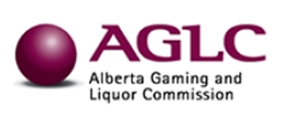
- Alberta Gaming and Liquor Commission

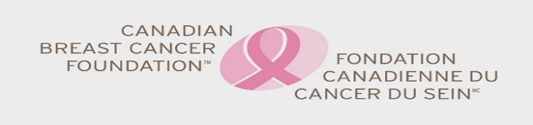
- Canadian Breast Cancer Foundation

- Citizenship and Immigration Canada (CIC)

- Edmonton Community Adult Learning Association (ECALA)
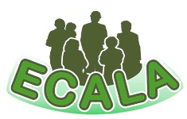

- Status of Women Canada

- Edmonton Community Foundation
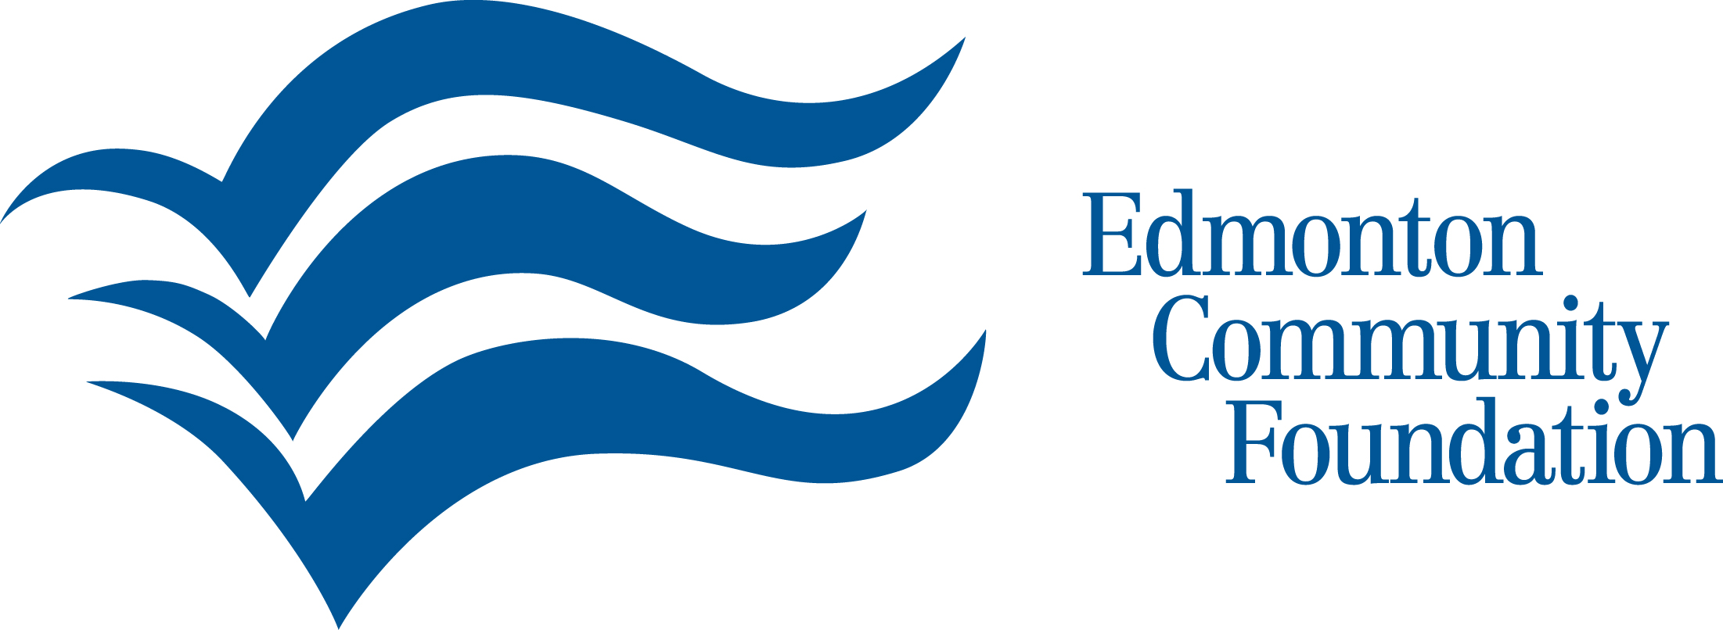

- City of Edmonton

- Stollery Children’s Hospital
